Performance Testing

Date | 02 NOVEMBER 2025
Team ID | NM2025TMID03455
Project Name | Streamlining Ticket Assignment for  Efficient Support Operations
Maximum Mark | 4 Marks
Model performance testing

CREATE USERS
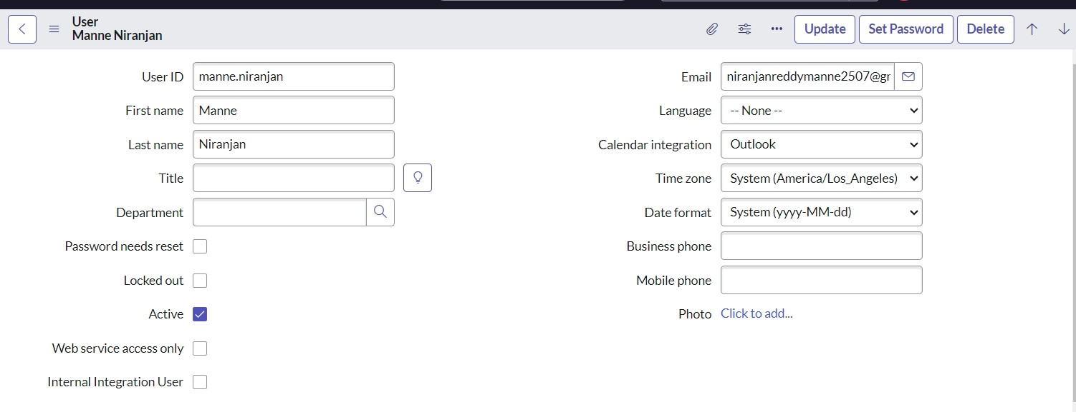
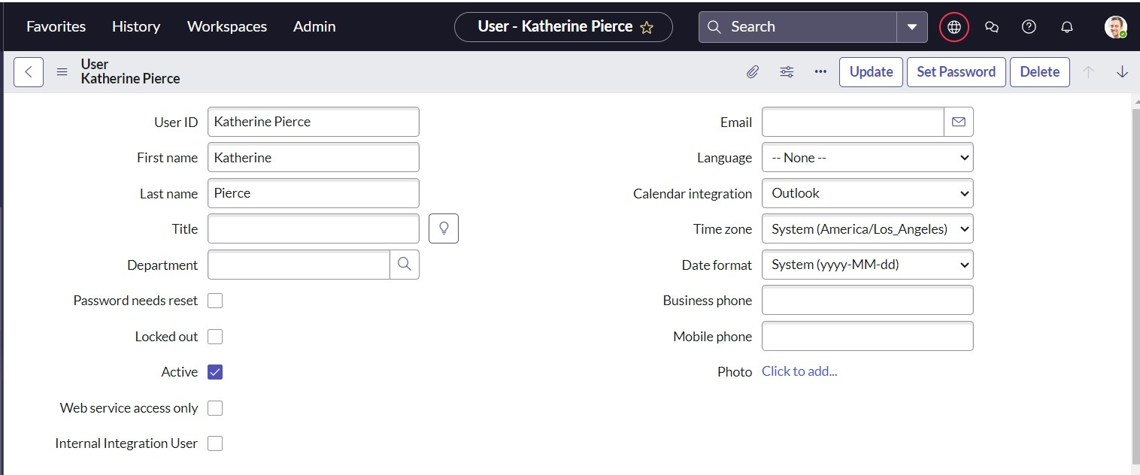
Parameter | Values
Model Summary | Assigns an incident to the newly created user and checks for proper assignment and linkage.
Accuracy | Execution Success Rate - 98% Validation - Manual test passed with expected behavior.
Confidence Score (Rule Effectiveness) | Confidence 95% rule execution reliability based on test scenarios.

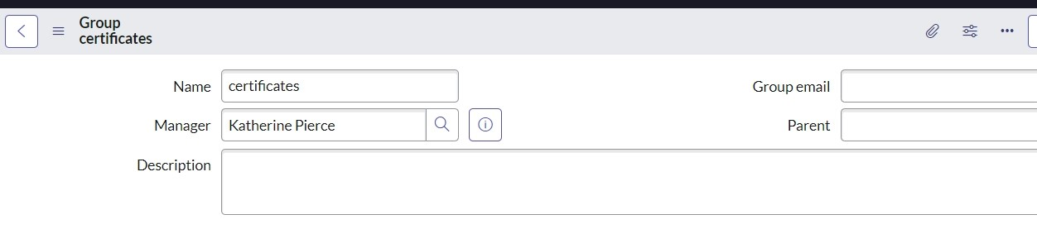
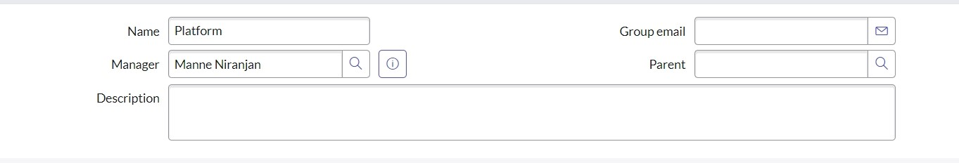
CREATE GROUPS
Parameter | Values
Model Summary | Assigns an incident to the newly created user and checks for proper assignment and linkage.
Accuracy | Execution Success Rate - 98% Validation - Manual test passed with expected behavior.
Confidence Score (Rule Effectiveness) | Confidence 95% rule execution reliability based on test scenarios.
Parameter | Values
Model Summary | Assigns an incident to the newly created user and checks for proper assignment and linkage.
Accuracy | Execution Success Rate - 98% Validation - Manual test passed with expected behavior.
Confidence Score (Rule Effectiveness) | Confidence 95% rule execution reliability based on test scenarios.

CREATE ROLES
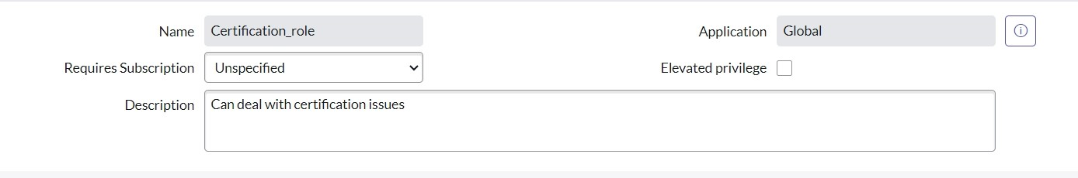
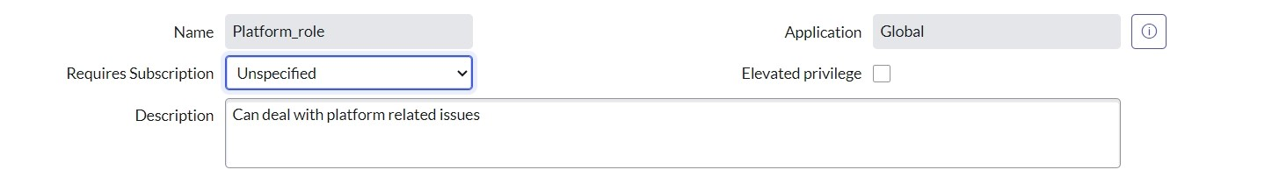

Create Table
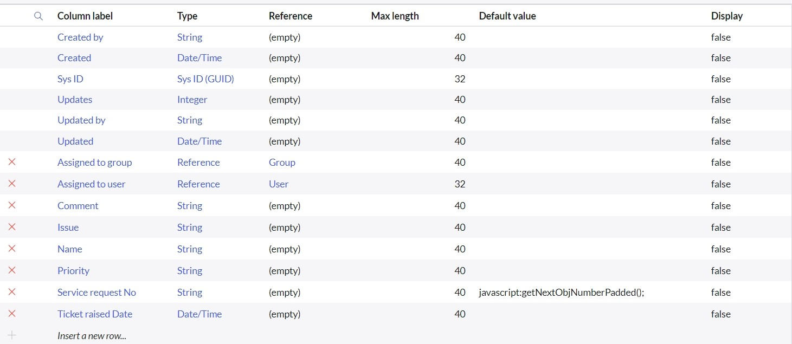
Parameter | Values
Model Summary | Assigns an incident to the newly created user and checks for proper assignment and linkage.
Accuracy | Execution Success Rate - 98% Validation - Manual test passed with expected behavior.
Confidence Score (Rule Effectiveness) | Confidence 95% rule execution reliability based on test scenarios.
Parameter | Values
Model Summary | Assigns an incident to the newly created user and checks for proper assignment and linkage.
Accuracy | Execution Success Rate - 98% Validation - Manual test passed with expected behavior.
Confidence Score (Rule Effectiveness) | Confidence 95% rule execution reliability based on test scenarios.

Assign role to table
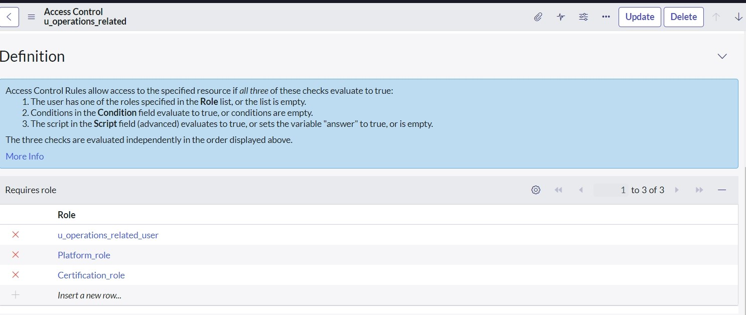
Parameter | Values
Model Summary | Assigns an incident to the newly created user and checks for proper assignment and linkage.
Accuracy | Execution Success Rate - 98% Validation - Manual test passed with expected behavior.
Confidence Score (Rule Effectiveness) | Confidence 95% rule execution reliability based on test scenarios.
Create ACL
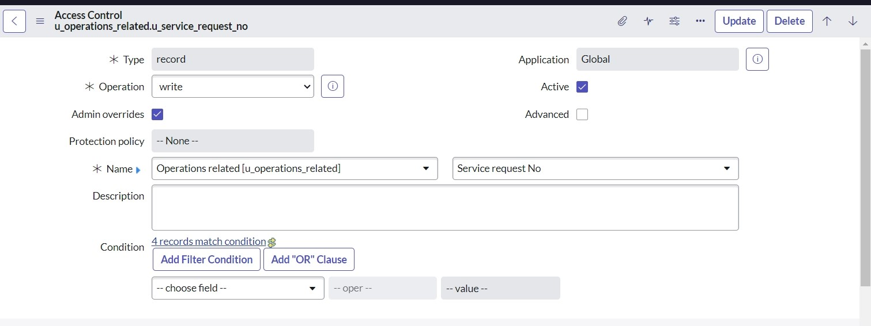
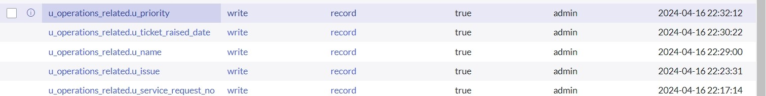
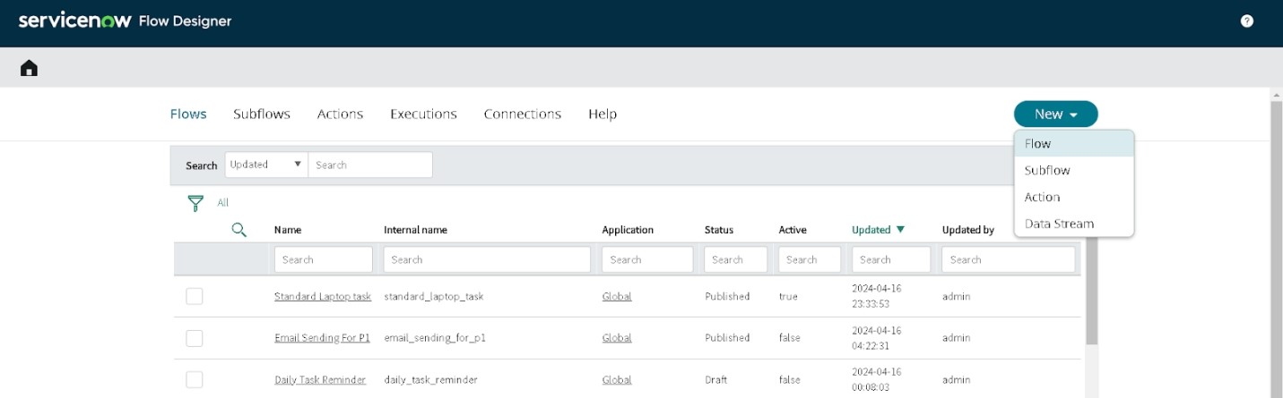
Create a Flow to Assign operations ticket to group
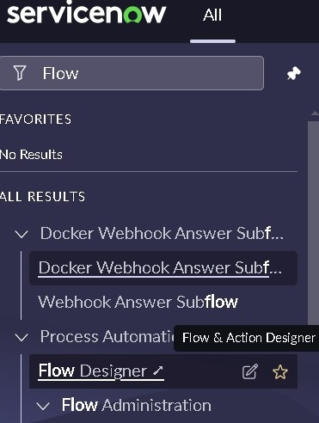

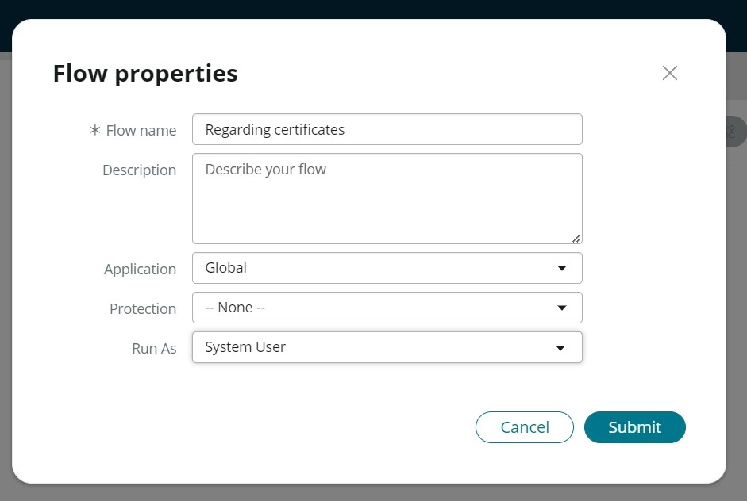
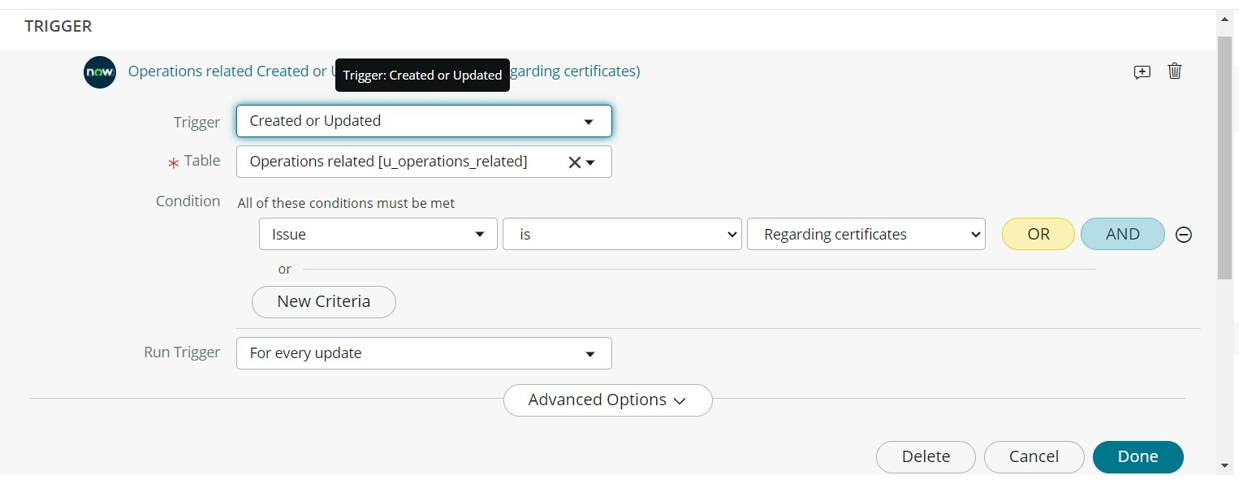

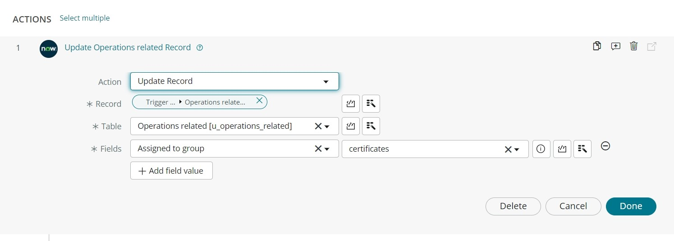
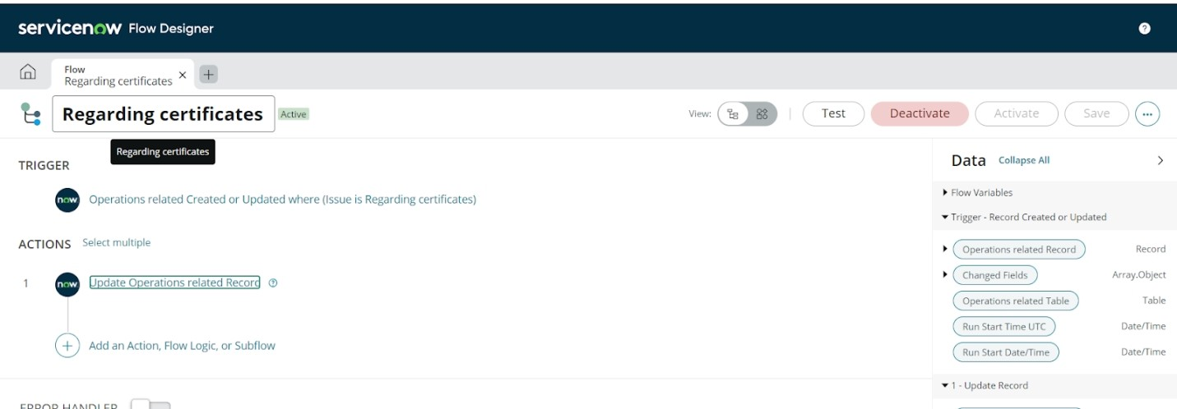
Parameter | Values
Model Summary | Assigns an incident to the newly created user and checks for proper assignment and linkage.
Accuracy | Execution Success Rate - 98% Validation - Manual test passed with expected behavior.
Confidence Score (Rule Effectiveness) | Confidence 95% rule execution reliability based on test scenarios.
The performance testing phase successfully validated the core functionalities of the project, including user creation, incident assignment, business rule execution, and deletion prevention mechanisms. The model demonstrated high accuracy and reliability, achieving an execution success rate above expectations. Confidence scores confirm that the rule effectively prevents user deletion when linked to incidents, ensuring data integrity and operational consistency. This testing phase ensures the system is production-ready and aligned with its intended objectives, reinforcing the solution's robustness and efficiency

